Isolation and culture of neonatal rat ventricular myocytes
After euthanasia, neonatal rats were surface-disinfected with 75% ethanol, and the thoracic cavity was opened to excise the hearts, which were then placed in ice-cold PBS. After all 20 hearts were collected, the atria and auricles were removed, leaving only the ventricular tissue. The ventricles were minced and digested overnight in 5 mL of 0.25% EDTA-free trypsin. Following centrifugation at 800 rpm for 5 minutes to remove the trypsin, 5 mL of filter-sterilized collagenase solution was added. The mixture was incubated in a 5% CO₂ incubator at 37°C and shaken every 5 minutes for a total digestion time of 15 minutes. After allowing the mixture to settle for 30 seconds, the digested supernatant was collected, and serum was added to a final concentration of at least 15%. This collagenase digestion step was repeated four times, with the supernatant collected each time, until digestion was complete. The combined supernatants were filtered through a 100 μm cell strainer and centrifuged at 800 rpm for 5 minutes, and the supernatant was discarded. The cell pellet was resuspended in 2 mL of 1× red blood cell lysis buffer, incubated for 5 minutes, and centrifuged again at 800 rpm for 5 minutes. The supernatant was removed, and the cells were cultured in F12/DMEM (1:1) medium supplemented with 10% serum and 1% penicillin-streptomycin in a 5% CO₂ incubator at 37°C for 1.5 hours to allow differential plating. Fibroblasts adhered to the culture dish, and the supernatant, containing the enriched cardiomyocytes, was collected. The cell concentration was adjusted to 1 × 10⁶ cells per milliliter, and the cells were seeded into 24-well plates, with 12 wells plated per plate to facilitate experimental grouping and subsequent imaging.
The cells were cultured in F12/DMEM (1:1) medium containing 10% serum and 1% penicillin-streptomycin in a 5% CO₂ incubator at 37°C for 36–48 hours. Once spontaneous beating was observed, the medium was replaced with F12/DMEM (1:1) medium supplemented with 10% serum, 1% penicillin-streptomycin, and 0.1% 5-bromodeoxyuridine (BrdU) for continued culture. The medium was changed every three days thereafter.

Model establishment

Baseline recording
At 36 hours after NRVM plating, the F12/DMEM (1:1) medium was replaced, and BrdU was added at a dilution of 1:1000 to inhibit fibroblast growth. Baseline beating activity of the NRVMs was recorded between 1 and 4 hours after medium change. A high-speed digital CMOS camera (Point Grey GS3-U3-51S5M-C) was connected to an Olympus inverted microscope. Video recording was performed using FlyCapture2 Camera Selection software (version 2.13.3.61). The contractile dynamics of the NRVMs were continuously recorded for 15 seconds at a frame rate of at least 60 frames per second. Subsequent treatments or interventions were performed after baseline recording.

Oxygen-glucose deprivation (OGD) model
The oxygen-glucose deprivation (OGD) model was used to model ischemia-like injury in NRVMs. NRVMs were washed twice with pre-warmed PBS (37°C), and the PBS was aspirated completely. Glucose-free DMEM medium supplemented with 1% serum and penicillin-streptomycin was then added. The cells were immediately subjected to hypoxic conditions and incubated at 37°C for 30 minutes. After OGD treatment, NRVM beating was recorded using the same method described above.

ISO treatment
Isoproterenol (ISO) was diluted with culture medium to concentrations of 1000, 500, 100, 10, and 1 nM. NRVMs were washed twice with pre-warmed PBS (37°C), and the PBS was aspirated completely. The cells were then incubated with ISO-containing culture medium for 1 hour in a 37°C, 5% CO₂ incubator. After stimulation, NRVM beating was recorded using the same method described above.

Calcium imaging
Calcium imaging was performed using the Fluo-4 AM calcium-sensitive fluorescent probe (Beyotime, S1060). The culture medium was aspirated from neonatal rat ventricular myocyte (NRVM) cultures, and the cells were washed three times with PBS. The probe was diluted with PBS to a concentration of 2 μM and incubated with the cells for 1 hour at room temperature. After discarding the dye solution, the cells were washed three times with PBS and then maintained in serum-free DMEM medium to preserve cell viability. Fluorescence intensity was subsequently recorded using a fluorescence microscope.

iPSC-derived cardiomyocyte culture
Commercial arrhythmogenic right ventricular cardiomyopathy (ARVC) disease-specific iPSC-derived cardiomyocytes were purchased from Nanjing Cosmos Biotechnology Co., Ltd. (CSM-H230040). Cells were cultured using the corresponding proprietary plating, thawing, and maintenance media. Cells were seeded at a density of 5 × 10⁵ cells per well in 24-well plates. Approximately 5 days after seeding, stable and consistent beating was observed, at which point video recording was performed.

Development Methodology of CellECGNet
CellECGNet is a label-free functional phenotyping workflow for videos of cardiomyocyte contraction. Starting from microscopy videos, the pipeline first estimates dense motion fields between adjacent frames, automatically constructs contraction-active regions of interest (ROIs), generates one-dimensional ROI motion traces, identifies contraction states, localizes key kinetic events, and further extracts parameters related to rhythm, contraction-relaxation timing, velocity, waveform morphology, spatial synchrony, and mechanical phenotypes.

Motion-field extraction and definition of motion magnitude
For an input video $I_{0},I_{1},…,I_{T}$, CellECGNet estimates a two-dimensional dense displacement field for each adjacent frame pair $I_{t}$ and $I_{t+1}$:
$$u_{t}(x,y)=\left(Δx_{t}(x,y),Δy_{t}(x,y)\right).$$
The motion-magnitude field is defined as the Euclidean norm of the displacement vector:
$$m_{t}(x,y)=‖u_{t}(x,y)‖_{2}=\sqrt{Δx_{t}(x,y)^{2}+Δy_{t}(x,y)^{2}}.$$
In the DEFORM-Net implementation, videos are processed at their native frame rates. For state recognition, motion fields are downsampled so that the shorter edge remains at least 80 pixels, preserving the dominant spatial motion structure while reducing downstream inference cost; for ROI-trace extraction and spatial synchrony analysis, the motion-magnitude information retains spatial alignment with the ROI. In addition to DEFORM-Net, the workflow also retains OpenCV DIS as an alternative motion-estimation backend.
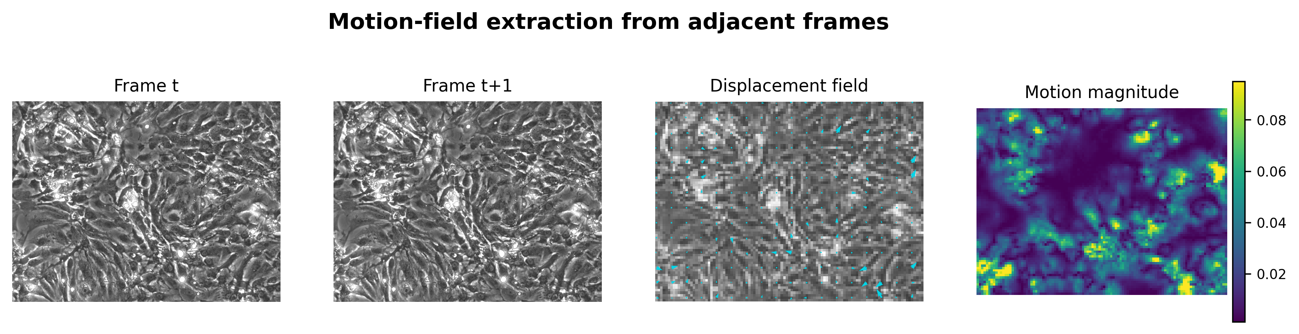
Figure S1. Schematic of motion-field extraction. Adjacent frames are used to estimate pixel-level displacement fields, which are then converted into motion-magnitude maps. Motion vectors preserve local motion-direction information, whereas motion-magnitude maps are used for ROI construction, ROI-trace aggregation, and spatial synchrony calculation.

Automatic ROI construction and generation of ROI motion traces
The ROI mask is automatically generated from the motion-magnitude sequence. First, the motion-magnitude field is divided into local patches, with a default patch size of 12 pixels. For the $p$-th patch, the patch-level motion sequence over time is computed as:
$$s_{p}(t)={mean}_{(x,y)∈p}m_{t}(x,y).$$
Local motion amplitude is defined as the difference between the 90th and 10th percentiles of the patch-level sequence:
$$A_{p}=Q_{0.90}\left(s_{p}(t)\right)-Q_{0.10}\left(s_{p}(t)\right).$$
To reduce the influence of global noise elevation on thresholding, the 25th percentile of patch amplitudes is used as the noise baseline:
$$b_{noise}=Q_{0.25}\left(\{A_{p}\}\right),$$
The baseline-subtracted motion amplitude is then obtained as:
$$A_{p}^{'}=max(A_{p}-b_{noise},0).$$
Candidate patches must satisfy both periodic activity criteria and an amplitude-threshold criterion. The amplitude threshold is defined as the 0.65 quantile among valid patches:
$$τ_{A}=Q_{0.65}\left(\{A_{p}^{'}:p∈P_{valid}\}\right).$$
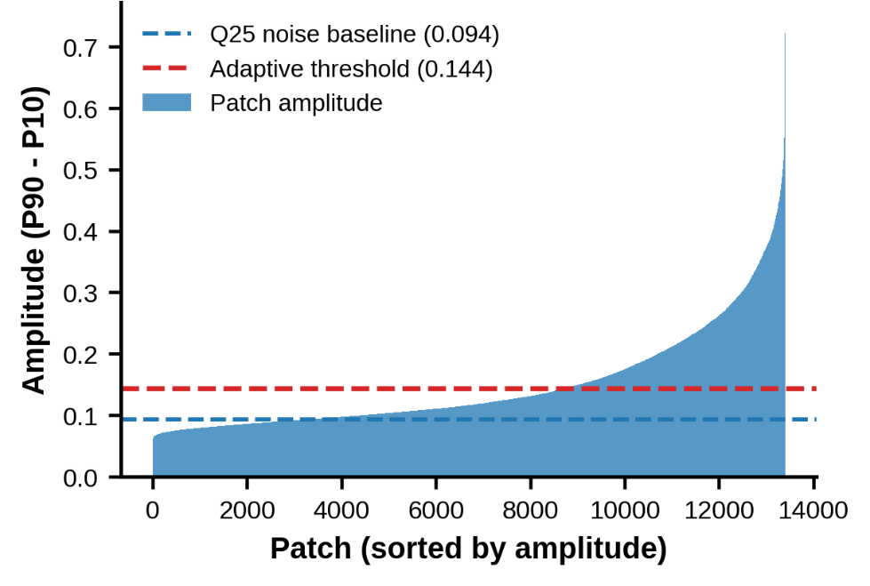
Figure S2. Patch-amplitude distribution and adaptive threshold. This panel shows the ranked distribution of patch motion amplitude $A_{p}=Q_{0.90}-Q_{0.10}$ and marks the Q25 noise baseline and adaptive amplitude threshold. It illustrates that ROI-construction thresholds are derived from the global patch-amplitude distribution rather than from a manually specified fixed value.
When texture information is available, CellECGNet uses Sobel gradient magnitude to construct a texture-preserving mask, retaining by default the 50% of pixels with the highest gradient magnitudes. Patches with texture coverage below 0.02 are excluded, and texture gating is applied before patch aggregation. Candidate ROI patches undergo $3×3$ morphological closing and opening, and small connected components with an area below 0.2% of the total number of patches are removed. The final patch-level mask is upscaled to the original video resolution and intersected with the texture mask to suppress blank or low-texture background regions.
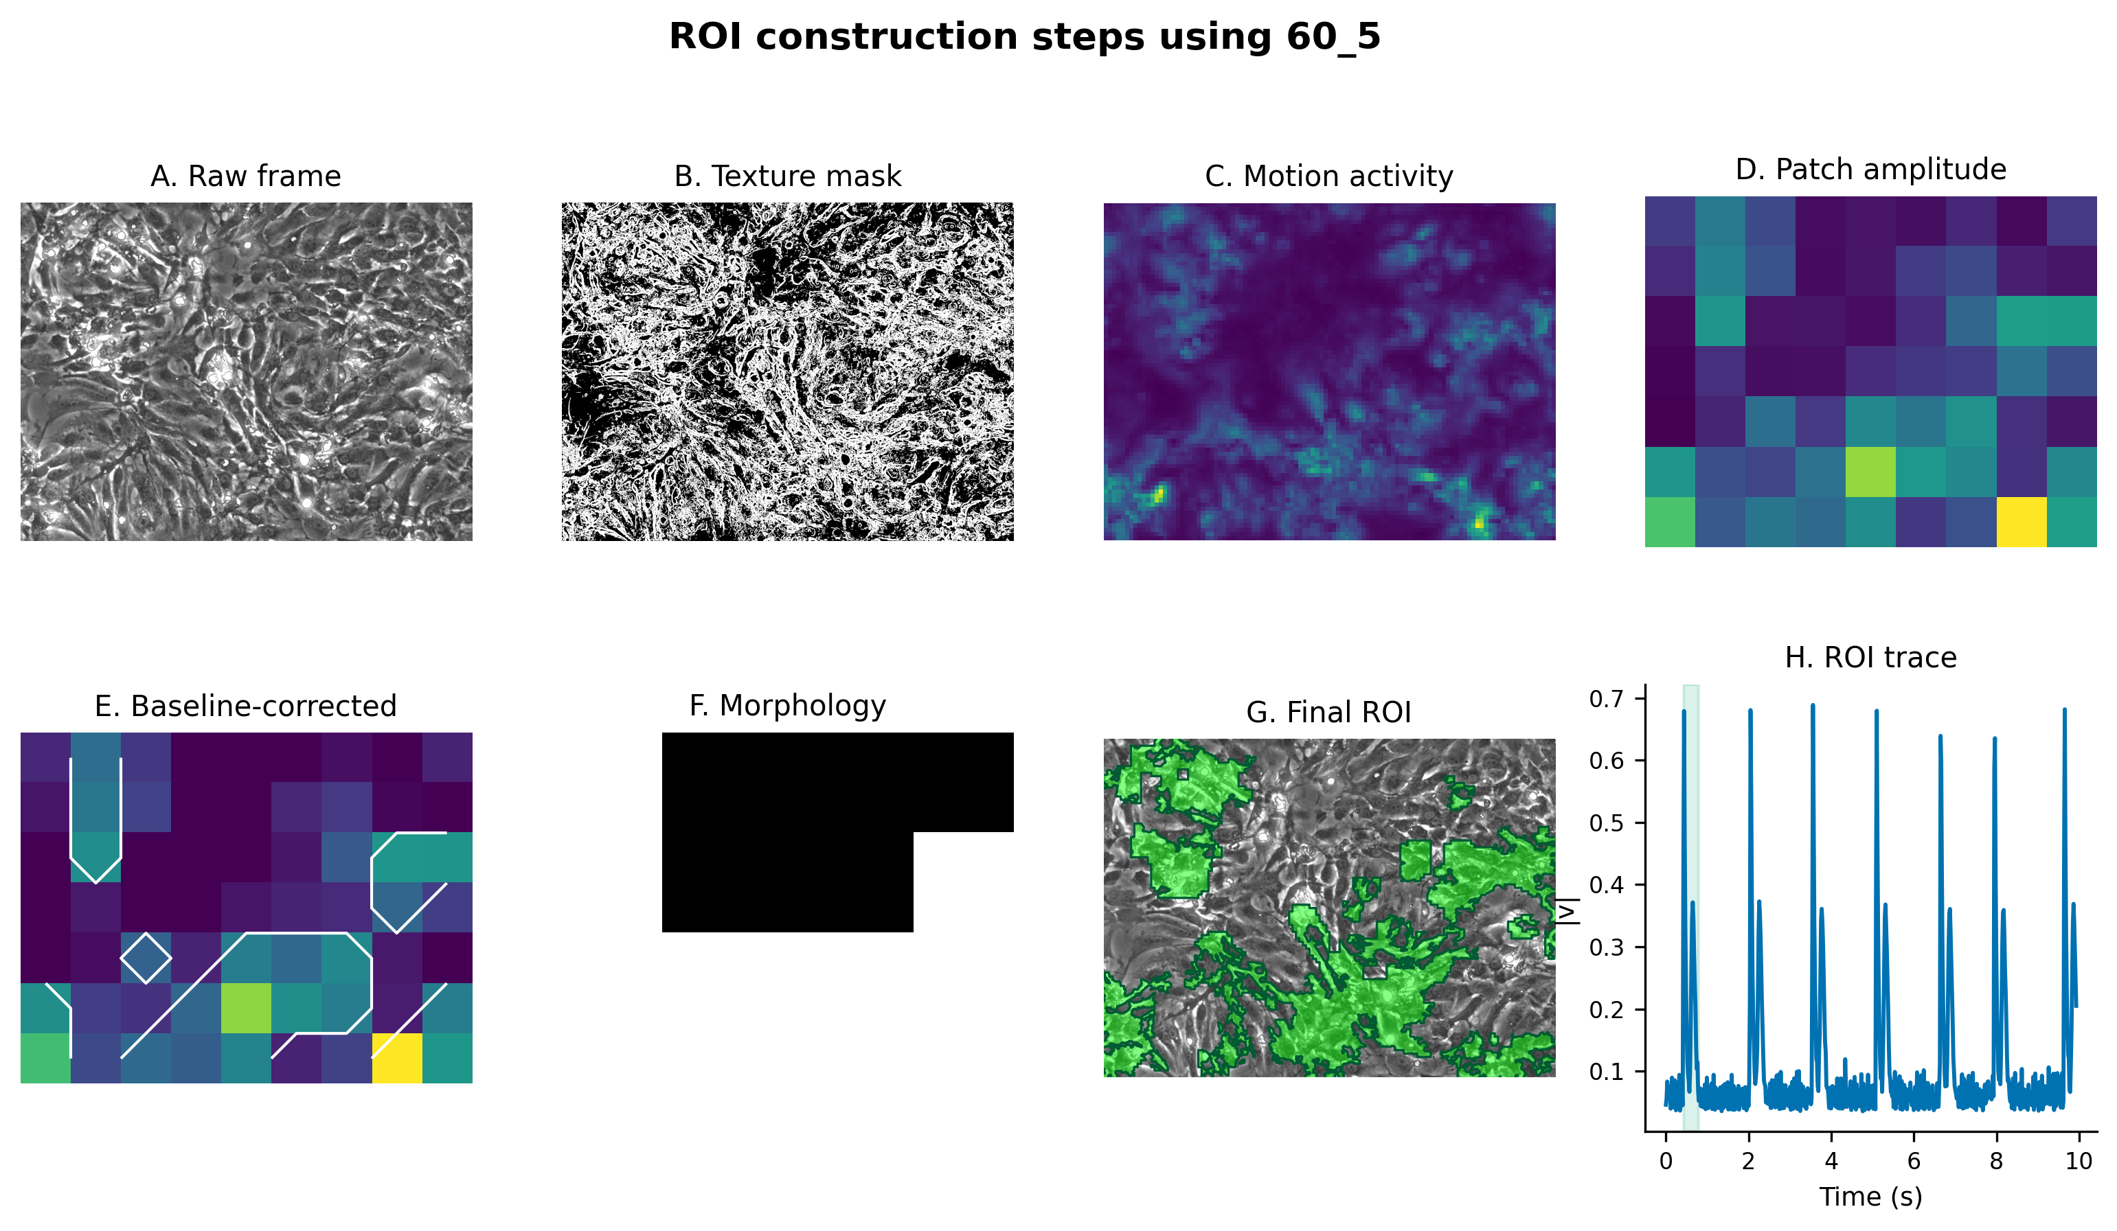
Figure S3. Steps for automatic ROI construction. The workflow includes the raw image, texture mask, motion-activity map, patch-amplitude map, noise-baseline subtraction, morphological cleanup, final ROI overlay, and ROI-trace generation. This figure was generated using the cached median_masked ROI output from the current analysis pipeline.
Given the final ROI $Ω$, the ROI motion trace is obtained by aggregating each inter-frame motion-magnitude map within the ROI. The default aggregation mode is median_masked:
$$r(t)={median}_{(x,y)∈Ω}m_{t}(x,y).$$
This one-dimensional trace represents the overall motion intensity of the contraction-active region within the field of view. In parallel, the motion-magnitude field under the ROI mask is divided into $8×8$ tiles for subsequent spatial synchrony analysis.
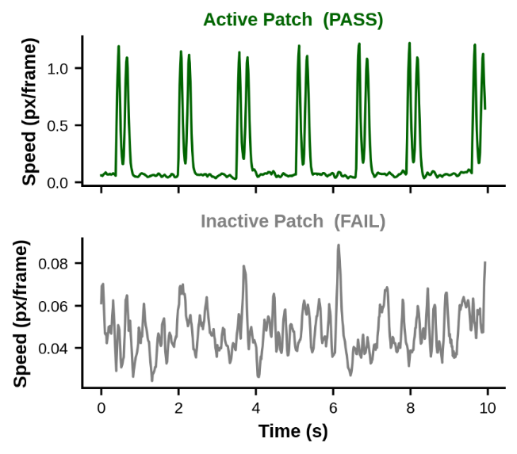
Figure S4. Comparison between active and inactive patch traces. By comparing screened active patches with inactive patches that failed the screening criteria, effective ROI regions can be seen to exhibit stable and periodic contraction peaks, whereas background or blank regions mainly show low-amplitude, nonperiodic noise.
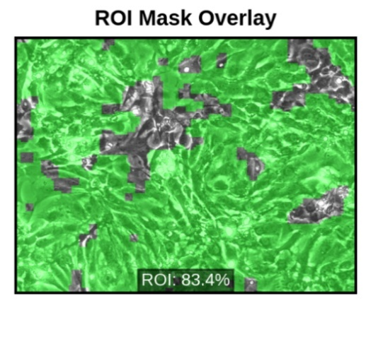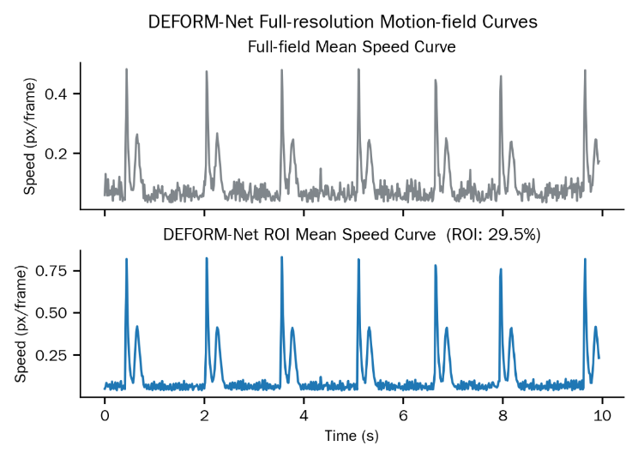
Figure S5. Comparison between full-field average and ROI traces. After low-texture or non-contractile background regions are excluded by the ROI mask, the ROI-averaged velocity trace shows higher contraction-peak amplitude and clearer periodic structure than the full-field average trace, improving the stability of subsequent state recognition and landmark localization.

Contraction-cycle analysis based on state recognition
Rather than relying solely on peak detection from a one-dimensional ROI trace, CellECGNet uses motion-field clips as the primary input for state recognition. Downsampled motion-field clips with a length of 8 frames and a stride of 1 frame are converted into pseudo-RGB representations and passed to a masked graph/motion autoencoder (MGMAE) to obtain embeddings. Let the MGMAE representation of the $i$-th clip be $e_{i}$, and let the directional motion feature be $d_{i}$. The combined feature can be written as:
$$h_{i}=\left[e_{i} , λ_{d}d_{i}\right],$$
The default directional-feature weight is $λ_{d}=2.0$. The combined representation is reduced to 16 dimensions and then passed to a two-state Gaussian hidden semi-Markov model (Gaussian HSMM). HSMM constrains the duration of each state segment, with a default minimum duration of 3 frames, maximum duration of 300 frames, and duration regularization lower bound of 5.0. The two states are assigned to motion or interval according to the within-state mean ROI motion magnitude:
$$z_{k}=\left\{\begin{matrix}motion, & {\overline{r}}_{k}=max({\overline{r}}_{1},{\overline{r}}_{2}), \\ interval, & otherwise.\end{matrix}\right.$$
The decoded state sequence is subsequently post-processed. Low-amplitude motion segments are filtered using a maximum-gap amplitude threshold and a resting-segment noise threshold; short interval segments are merged when their duration is less than 0.3 times the median interval duration; and internal short resting gaps between two motion segments are bridged when duration and amplitude criteria are met. The default maximum bridgeable gap is 180 ms, the maximum merged event duration is 1200 ms, the minimum flanking motion duration is 45 ms, and the minimum peak amplitude is 30% of the video-level median motion peak. Automatic gap-thresholding can be enabled, but its upper bound is limited to 800 ms.
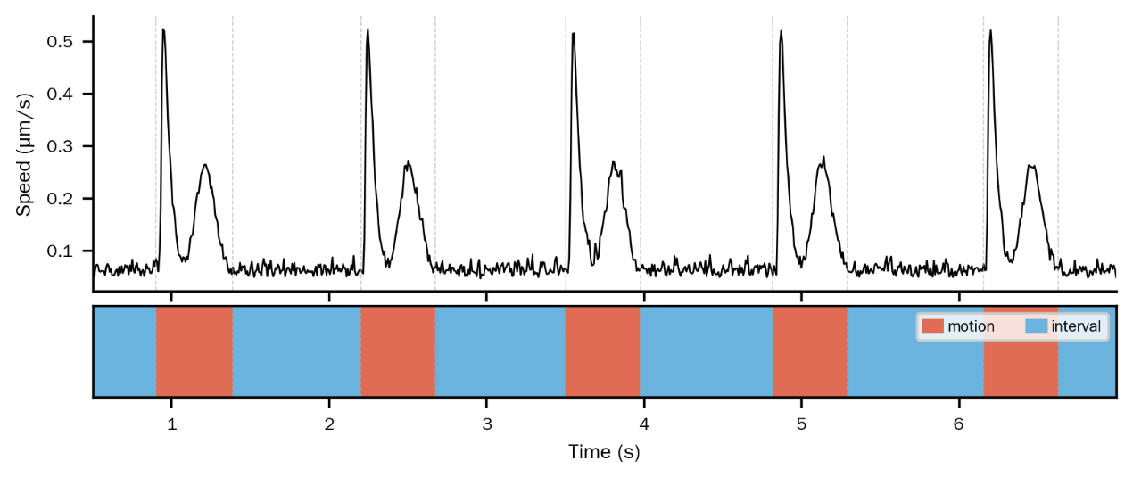
Figure S6. HSMM decoding result and state mapping. The Gaussian HSMM partitions the time series into motion and interval states. Motion segments correspond to contraction-relaxation activity intervals, whereas interval segments correspond to relatively quiescent intervals between cycles.

Definition of the five kinetic landmarks
Each complete contraction cycle is described by five landmarks: Start, MCS, CRT, MRS, and End. The interval from Start to End is defined as one complete contraction-relaxation cycle. Candidate motion segments shorter than 6 frames are excluded. MCS and MRS are defined as the two dominant motion peaks within the same motion segment, with an exclusion radius imposed between them:
$$ρ=min\left(max\left(\frac{L_{seg}}{8} , 2\right),6\right),$$
Here, $L_{seg}$ denotes the length of the motion segment. CRT is defined as the local minimum between MCS and MRS:
$$t_{CRT}=\backslash arg\min_{t∈[t_{MCS},t_{MRS}]}r(t).$$
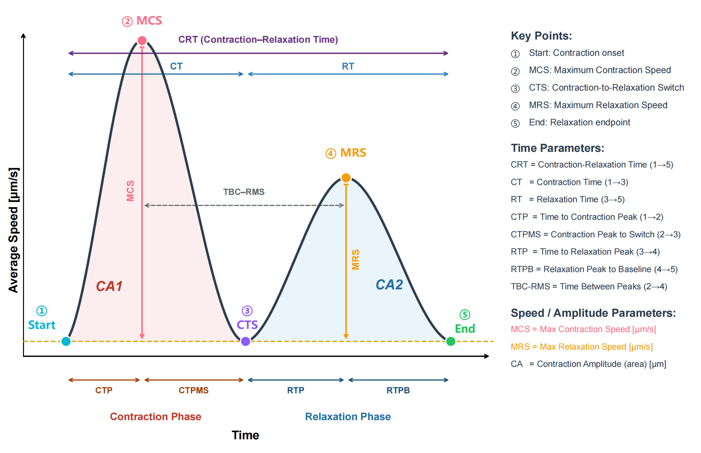
Figure S7. Schematic of the five landmark locations and parameter definitions. Start, MCS, CRT, MRS, and End jointly define a complete contraction-relaxation cycle. The figure also illustrates contraction time (CT), relaxation time (RT), peak timing, and the kinetic relationships among landmarks.

Functional parameter extraction
Based on the ROI trace and the five landmarks, CellECGNet extracts cycle-level and video-level parameters. Temporal parameters include:
$$CRT=t_{End}-t_{Start},$$
$$CT=t_{CRT}-t_{Start},RT=t_{End}-t_{CRT},$$
$$CTP=t_{MCS}-t_{Start},RTP=t_{MRS}-t_{CRT}.$$
Velocity-related parameters include MCS, MRS, the MCS/MRS velocity difference, and CRT velocity. When pixel-size calibration is available, motion magnitude is converted using the pixel-size factor; otherwise, the default pixel value is 1.0. Contraction amplitude is calculated as the area of the systolic trace above baseline. The baseline is defined as:
$$b=min\left(r(t_{Start}),r(t_{CRT})\right),$$
The discrete contraction area is therefore:
$$CA=\sum_{t=t_{Start}}^{t_{CRT}}{max(r(t)-b,0)Δt.}$$
Video-level rhythm parameters include the mean RR interval, coefficient of variation of RR intervals, pause ratio, suspected missed-beat ratio, strong-weak alternans index, long-short alternans index, post-event ratio, multipeak index, and cycle-morphology consistency.

Spatial synchrony calculation
Spatial synchrony is calculated from the motion-magnitude field under the ROI mask. The ROI is divided into $8×8$ local tiles, and each tile yields a local motion trace $r_{j}(t)$. During the contraction phase $\left[t_{Start} , t_{CRT}\right]$, the local amplitude of each tile is:
$$A_{j}=\max_{t}r_{j}(t)-\min_{t}r_{j}(t).$$
When $A_{j}≥max({10}^{-6},0.25A_{global})$, the tile is considered an active tile. For all active tiles, the local peak time is calculated as:
$$t_{j}^{peak}=\backslash arg\max_{t∈[t_{Start},t_{CRT}]}r_{j}(t).$$
The standard deviation of local peak timing is defined as:
$$σ_{peak}=std\left(\{t_{j}^{peak}\}\right).$$
The contraction synchrony index (CSI) is defined as an exponential decay of peak-time dispersion relative to contraction duration:
$$CSI=exp\left( − \frac{σ_{peak}}{max(0.25T_{contract},1/fps)}\right),$$
Here, $T_{contract}=t_{CRT}-t_{Start}$. CSI values closer to 1 indicate more synchronized peak timing across local regions.

Rule-based mechanical phenotype screening
The first-layer rule module is designed for interpretable mechanical phenotype screening rather than clinical diagnosis. It identifies structural contraction patterns, including rhythm instability, pause/dropout-like behavior, paired-beat-like behavior, alternans-like behavior, aftercontraction-like behavior, multipeak-complex-like behavior, desynchronized contraction, and mixed mechanical abnormality.
Rule triggers are primarily based on absolute thresholds or reference-normalized z scores:
$$z=\frac{x-μ_{ref}}{σ_{ref}}.$$
For example, rhythm instability may be triggered when z scores for RR-interval-variability-related parameters exceed 2.0; pause/dropout may be triggered when the pause ratio is at least 0.15 or the missed-beat ratio is at least 0.20; and desynchrony may be triggered when CSI is below 0.50 or when the CSI z score is below -2.0. Continuous kinetic abnormalities, such as delayed relaxation or prolonged contraction, are retained as quantitative evidence rather than being used directly as primary rule-layer labels.

Deep-learning functional phenotype classification
The second-layer functional phenotype classifier uses a supervised multimodal TCN-BiGRU model. Model inputs include the normalized ROI trace, its temporal derivative, and video-level contraction parameters; rule-layer labels and manual annotation fields are not used as model inputs. Let the ROI-trace input be $x$, the derivative be $Δx$, and the parameter vector be $p$. The model can be summarized as:
$$c=BiGRU\left(TCN\left([x,Δx]\right)\right),$$
$$q=f_{param}(p),\overset{^}{y}=softmax\left(f_{cls}([c,q])\right).$$
The TCN consists of three one-dimensional convolutional blocks with 32, 48, and 48 channels, a kernel size of 3, and dilation rates of 1, 2, and 4, respectively. The TCN output is passed to a bidirectional GRU with a hidden dimension of 32, yielding a 64-dimensional curve representation. The parameter branch consists of 96 hidden units, batch normalization, ReLU activation, dropout, and a 64-dimensional output. The final classification head predicts three phenotypic classes: healthy-like, arrhythmia-like, and contractile-dysfunction-like.
Annotated data were split at the sample level into a training set and an internal hold-out test set, with a hold-out proportion of 20% and a random seed of 42. Model selection and hyperparameter comparison were performed within the training set. Candidate models were trained for up to 300 epochs, with an early-stopping patience of 35 and a batch size of 32. The main TCN-BiGRU parameter model used the AdamW optimizer with a learning rate of $6×{10}^{-4}$, weight decay of $2×{10}^{-3}$, and dropout of 0.30. The enhanced focal-loss version used balanced sampling and conservative time-series augmentation during training. Model performance was evaluated using accuracy, macro-F1, balanced accuracy, class-wise precision/recall, confusion matrices, and one-vs-rest ROC/AUC.

Benchmark Design and Evaluation Strategy

Benchmark dataset construction and manual annotation
To systematically evaluate the robustness of CellECGNet under different video perturbations, the benchmark dataset was constructed from five cardiomyocyte contraction microscopy videos. Each original video was manually annotated for contraction-cycle landmarks, including contraction onset, maximum contraction speed, contraction-to-relaxation transition, maximum relaxation speed, and relaxation end. Manual annotation was based primarily on frame-by-frame inspection of motion fields and was cross-referenced with corresponding Ca²⁺ imaging signals to improve the physiological consistency of landmark definitions.

Temporal perturbations
Temporal perturbations were generated by preserving manually annotated landmark frames while selectively deleting non-landmark frames. This design was used to simulate common temporal-structure changes in cardiomyocyte contraction videos, including time to peak, contraction/relaxation ratio, apparent amplitude, waveform asymmetry, local waveform morphology, and cycle-level rhythm jitter. Let the original frame index be $i$, and let the retained-frame set be $R$. After frame deletion, the new index of an original landmark $k$ is obtained from its rank position within the retained frames:
$$k^{'}=\left|\{i∈R:i≤k\}\right|-1.$$
Six temporal perturbation schemes were used. In all schemes, only non-landmark frames were removed, while manually annotated Start, MCS, CRT, MRS, and End frames were retained. Thus, the procedure required neither frame interpolation nor video resampling and avoided introducing additional image-synthesis artifacts. The perturbation types were defined as follows.
T1 TTP Scale: non-landmark frames were selectively removed within the Start-MCS interval or adjacent temporal regions to alter the relative time to peak from contraction onset to the maximum contraction speed event, thereby simulating early-peak or late-peak temporal compression.
T2 CT/RT Ratio: non-landmark frames were removed separately from the contraction or relaxation phase to alter the relative ratio between contraction time and relaxation time, thereby simulating fast-contraction/slow-relaxation or slow-contraction/fast-relaxation dynamics.
T3 Amplitude: non-landmark frames near the peak or near the baseline were removed to alter the apparent amplitude and peak intensity observed in the discretely sampled motion trace, thereby evaluating robustness to sampling-induced changes in amplitude presentation.
T4 Asymmetry: different frame-deletion densities were applied to the contraction upstroke and relaxation downstroke, creating asymmetric temporal structure on the two sides of the waveform and simulating inconsistent slopes between contraction and relaxation.
T5 Waveform: non-landmark frames were selectively removed within local waveform regions to alter shoulder peaks, inter-peak intervals, or local waveform complexity, thereby simulating non-standard contraction waveforms and local shape perturbations.
T6 Jitter: a small number of non-landmark frames were randomly removed between cycles or within local windows inside a cycle, producing mild fluctuations in inter-frame intervals and event spacing to simulate rhythm jitter and nonuniform temporal sampling.

Spatial perturbations
Spatial perturbations were used to simulate changes in imaging quality and field-of-view conditions. For each original video, 18 spatially perturbed versions were generated, comprising 6 perturbation classes and 3 severity levels per class: Poisson-Gaussian noise, Gaussian blur, brightness/contrast change, resolution degradation, rotation, and spatial drift. Because spatial perturbations did not alter the temporal structure of the video, the ground-truth landmarks for each contraction cycle were unchanged.

Comparator tools and parameter settings
Both temporally and spatially perturbed videos were used to compare the detection performance of CellECGNet, MUSCLEMOTION, and ContractionWave. CellECGNet used a fixed analysis pipeline without manual tuning for individual videos. To avoid underestimating the performance of comparator tools, MUSCLEMOTION and ContractionWave were each evaluated with a parameter grid search, and the oracle-tuned result with the highest F1 score was selected for each perturbed video.
The MUSCLEMOTION search parameters included detection threshold, temporal half-window size, and Gaussian blur coefficient. Threshold values were 10%, 15%, 20%, 25%, 30%, 40%, and 50%; half-window sizes were 5, 11, 15, 21, and 31 frames; and blur $σ$ values were 5, 10, and 15. The ContractionWave search parameters included delta_divisor values of 2.0, 2.5, 3.0, 4.0, 5.0, and 6.0, combined with three smoothing settings: no smoothing, Savitzky-Golay smoothing, and moving-average smoothing.

Evaluation metrics
All tools output the main contraction-related motion signal and detected contraction-cycle landmarks. Detected cycles were matched to manual ground truth. The temporal intersection-over-union between a detected cycle $D$ and a ground-truth cycle $G$ was defined as:
$$IoU(D,G)=\frac{\left|D ∩ G\right|}{\left|D ∪ G\right|}.$$
A detected cycle was considered a matched detection when the IoU of the Start-to-End interval was at least 0.6. Precision, recall, and F1 were defined as:
$$P=\frac{N_{matched}}{N_{detected}},R=\frac{N_{matched}}{N_{GT}},$$
$$F1=\frac{2PR}{P+R}.$$
Landmark localization error was evaluated using mean absolute error (MAE) and root mean square error (RMSE):
$$MAE=\frac{1}{N}\sum_{i=1}^{N}{|}{\overset{^}{t}}_{i}-t_{i}|,$$
$$RMSE=\sqrt{\frac{1}{N}\sum_{i=1}^{N}{(}{\overset{^}{t}}_{i}-t_{i})^{2}}.$$
Evaluation included contraction onset, CRT, relaxation end, MCS, and MRS.

